1.1
Connection :
- Dependence invercion.
- The connection must be an interface.

1.2
Connection Manager :
- Breaking single responsibility because he is doing more than one task

1.3
Jop Executor :
- Breaking the Open Close function is because it contains if else statements and also depends on a Connection, and a Connection is not an interface.

- Breaking single responsibility .

1.4
Job :
- It depends on the user

1.5
Heavy Templet :
- Breaking single responsibility because he is doing more than one task (create goeinstance ) .

1.6
Templet Manager :

- Breaking single responsibility and duplicate .

1.7
User :
- Loose coupling I used it directly from the Job class.
- Dependency inversion It needs to be an interface

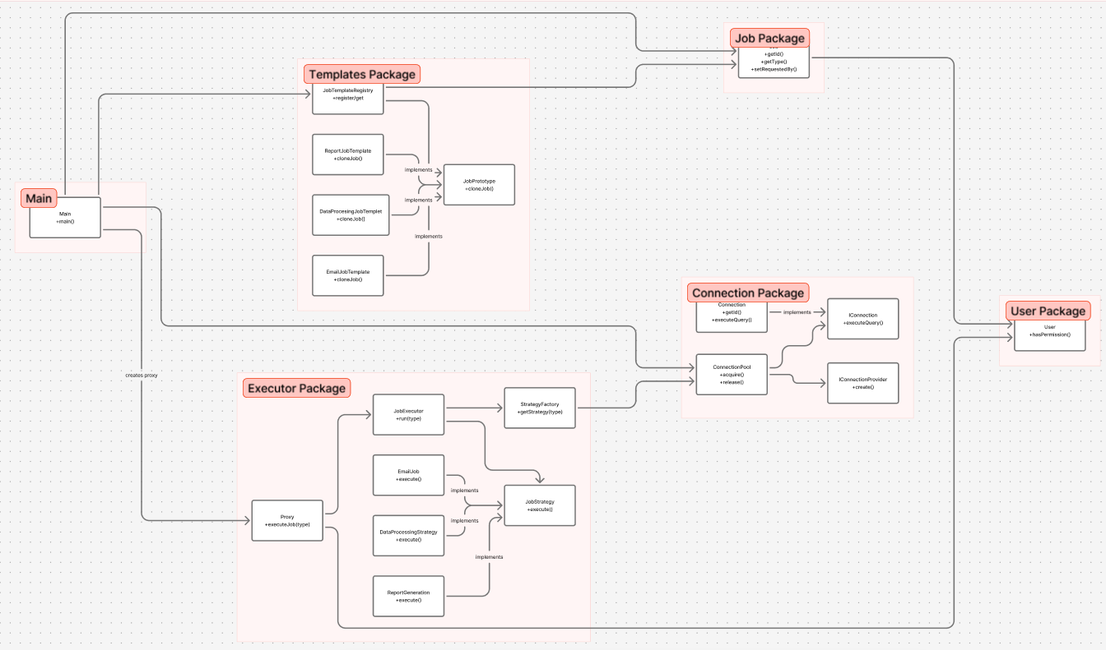

1. Why each design pattern was chosen

- Prototype Pattern
Chosen because job templates are heavy to build, and cloning them is much faster and more efficient.
- Strategy Pattern
Chosen to eliminate long if/else execution logic and cleanly separate execution behaviors for each job type.
- Proxy Pattern
Chosen to add permission checks, logging, timing, and connection management without modifying the real executor.

2. What alternatives you considered

- For Prototype
Factory Pattern (rejected: creates new heavy objects every time)
Singleton (rejected: cannot support multiple job instances)
- For Strategy
Switch-case or if/else (rejected: unmaintainable)
Command Pattern (rejected: more complex than needed)
- For Proxy
Inheritance from JobExecutor (rejected: breaks separation of concerns)
Manually adding checks inside executor (rejected: creates God class)

3. How the patterns interact
Prototype creates reusable templates and provides cloned jobs.
Strategy executes the cloned jobs using the correct behavior.
Proxy controls the execution process before and after the strategy runs.

4. How the architecture improves scalability, flexibility, and maintainability
- Scalability:
Fast cloning, connection pooling, and cleaner execution flow support high load.
- Flexibility:
New job types, templates, or strategies can be added without modifying existing code.
- Maintainability:
Each class has a single responsibility, no long if/else, and well-separated layers.

How your refactoring resolves the issues ?
.1Removes repeated heavy template creation.
.2Eliminates if/else logic in the executor.
.3Adds permission validation and security.
.4Adds logging and execution-time measurement.
.5Ensures safe database connection handling.
.6Reduces complexity and prevents God classes.
.7Makes the system modular, clean, and easy to extend.

